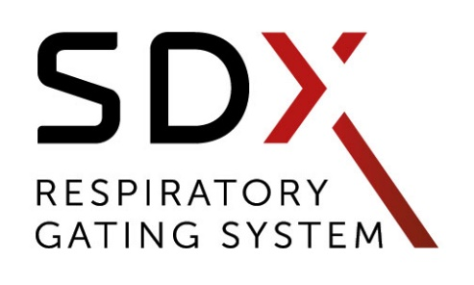

FREQUENTLY ASKED QUESTIONS

Why do I need SDX if I already have a camera system?
In external gating, the tumor position is derived using the external breathing signals, which can be a source of error. Variations in patient breathing, changes in tumor size or shape, patient weight loss or gain, abdominal contents and ascites can change the relationship between the tumor motion and surrogate signal, increasing risk of toxicity to OAR’s and healthy tissue. For 4D CT, the largest source of error is irregular patient respiration, causing artifacts in image re-sorting and reconstruction.
SDX complements camera systems, ensuring consistency between external and internal information to maintain a regular and reproducible patient breathing pattern from imaging through the final treatment session.

Why is voluntary-breath hold the preferred method for DIBH?
Many patients and physicians prefer the concept of voluntary breath hold to active breath holding. Active breath hold has been shown to cause anxiety for the patient, and in addition, it’s possible for a patient to overshoot the desired breath-hold volume if potentially inhaling too deeply at the time of cutoff.
Patient cooperation and comfort are an important consideration in radiotherapy, particularly for patients with compromised pulmonary status. DIBH is achievable with more than 95% of patients using the SDX visual-guidance spirometry goggles, despite lung pathology.

How long is the delivery, installation and training process?
Providers can expect delivery of their new system in less than two weeks anywhere in the world. Installation time can vary, from as little as a few days to a maximum of 45 days, dependent upon the client’s timeline.

Are there consumables?
There are three types of consumables for SDX: Mouthpiece, noseclip, and anti-bacterial and viral filters. To keep costs low (approx.. $1US per item), we coordinate a direct relationship between our providers and vendors - Vitalograph and GVS.

What are the COVID -19 protocols for use?
Consistent with the product’s user manual, the single use of antibacterial filters is always required to avoid any cross-contamination between patient breathing and the SDX® System. For each patient, providers use a new nose-clip and a mouthpiece for avoiding any oral and nasal leakage. Full Covid-19 protocols are available upon request.

DYN'R US
(United States)
(786) 862-3539
annabelle@dynr.com
350 NE 75th St, Suite 10
Miami, FL 33138
United States

DYN'R Medical Systems
(Worldwide)
+33 442 210 734
maxim@dynr.com
35 Rue Pierre Simon Laplace – Z.I les Milles
13290 Aix-en-Provence
France

